**Charles Péguy (1873-1914)**

French writer of the beginning of the 20th century, Charles Péguy was a socialist, a *dreyfusard*, a republican, a nationalist, a catholic, a mystic, successively or at the same time. Throughout his various identities, he remained first and foremost attached to literature.

Born in 1873, son of a carpenter and an upholsterer, rising from the Ecole normale of Orléans for primary school teachers to the prestigious Ecole Normale Supérieure of Paris-Ulm, in his youth Péguy incarnated the meritocratic success idealized in the Third Republic, benefiting from a state policy that he would later call: “school follies” (“les folies scolaires”). Péguy was affiliated with the Socialist Party alongside many French intellectuals and he supported the Jewish officer during the Dreyfus Affair. He made his literary debut by publishing his *Cahiers de la Quinzaine* in 1900. He would oversee this journal until his last days, publishing his own texts but also those of Romain Rolland, Julien Benda, Daniel Halévy, Georges Sorel, André Suarès, or Bernard-Lazare.

The *Mystery of the Charity of Joan of Arc (Le Mystère de la Charité de Jeanne d’Arc,* 1910) would remain his only literary success; in it he praises - through Jeannette, his growing heroine - an almost naïve, modest, rural, liturgical and firmly patriotic Catholicism. In *Our Youth* (*Notre Jeunesse*), Péguy breaks with many *dreyfusards* (Jaurès in the first place) whom he pejoratively associates with the “intellectual party” responsible for “having betrayed the mystical in order to do politics” – the mystical consisting in devoting oneself to a cause and politics in exploiting it. Religious poetry would follow (including *Eve* in 1913) in which a game of repetition and variation is instigated: the writing of Péguy follows his iterative way of thinking time; the texts reuse the same intertwining threads, forming different patterns according to their various subjects.

From the reform of the Humanities in 1902 until his last years, Péguy denounced the takeover by Sorbonne historians of the French education system. Péguy’s repetitive style challenges the rigidity of their positivist methods, performing Bergson’s emphasis on memory and duration instead of following a chronological and horizontal vision of time. He extensively criticized their belief in an empty historical science: as *Clio*, the muse of history in an eponymous posthumous work, asserts, “history is always an amateur, memory, aging is always a professional.” In *L’Argent* and *L’Argent (suite)*, Péguy persisted in his polemics, lampooning the pacifists on the eve of the First World War: “Destroying the homeland, they destroy themselves.”

On the 5th of September 1914, he was killed by a bullet at the front of Villeroy.

“After so much battling an eternal peace;  
After so much war an eternal victory;  
After so much misery an eternal glory;

After so much baseness an eternal rise;

After so much contesting an uncontested kingdom.”

The *Mystery of the Charity of Joan of Arc* (my translation) - OC P, p436

*References and further readings:*

*Complete works:*

* *Œuvres poétiques complètes* (1941)*,* ed. Jean Bastaire,Gallimard, Bibliothèque de la Pléiade
* *Œuvres en prose complètes* (3 vol. : 1987, 1988, 1992)*,* ed. Robert Burac,Gallimard, Bibliothèque de la Pléiade

*List of important works:*

* *Jeanne d'Arc,* 1897
* *De Jean Coste*, 1902
* *La thèse. De la situation faite à l’histoire dans la philosophie générale du monde moderne*, unfinished, 1905-1909
* *Le Mystère de la charité de Jeanne d'Arc*, 1910
* *Notre jeunesse*, 1910
* *Le Porche du Mystère de la deuxième vertu*, 1912
* *Ève*, 1913
* *L'Argent,* and *L’argent (suite),* 1913
* *Note sur M. Bergson et la philosophie bergsonienne*, 1914
* *Clio. Dialogue de l'histoire et de l'âme païenne*, posthumous

*Selected translation to English:*

* *The Portal of the Mystery of Hope* (2005), translated by David Louis Schindler Jr., Eerdmans Publishing Co.

*Critical works:*

* Romain Rolland (1944), *Charles Péguy,* Albin Michel
* Robert Burac (1994), *Charles Péguy : La révolution et la grâce,* Laffont
* Marie Gil (2011), *Péguy au pied de la lettre,* Edition du Cerf

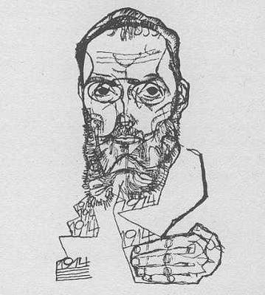Péguy sketched by Egon Schiele, *Die Aktion* (1914)